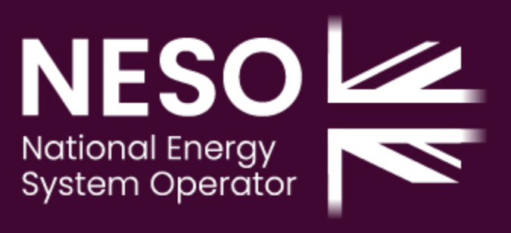 |  |  |  |  |  |  |  |  |  |  |  |  |  |  |  |  |  |  |  | Instruction to your  Bank or Building Society  to pay by Direct Debit
Please fill in the whole form including official use box and send it to: |  |  |  |  |  |  |  |  |  |  |  |  |  |  |  |  |  |  |  | Service User Number
National Energy System Operator Ltd  NESO  Order to Cash  Faraday House  Gallows Hill  Warwick  CV34 6DA |  |  |  |  |  |  |  |  |  |  |  |  |  |  |  |  |  |  |  | 43 | 5 | 1 | 083 | 8 | 3
FOR National Energy System Operator Ltd OFFICIAL USE ONLY
This is not part of the instruction to your Bank or Building Society.

In the “Reference” box below, please quote your NESO customer account number shown on your invoice.

Please also provide a telephone contact number & email address for any queries:

Name(s) of Account Holder(s)
Bank/Building Society account number
Branch Sort Code |  |  |  |  |  |  |  |  |  |  |  |  |  |  |  |  |  |  |  | Instruction to your Bank or Building Society  Please pay National Energy System Operator Ltd Direct Debits from the account detailed in this Instruction subject to the safeguards assured by the Direct Debit Guarantee. I understand that this Instruction may remain with National Energy System Operator Ltd and, if so, details will be passed electronically to my Bank/Building Society.
Name and full postal address of your Bank or Building Society
To: The Manager |  |  |  |  |  |  |  |  | Bank/Building Society
Address |  |  |  |  |  |  |  |  |  |  |  |  |  |  |  |  |  |  |  | Signature(s)
 |  |  |  |  |  |  |  |  |  |  |  |  |  |  |  |  |  |  |  | Print Name(s)
 |  |  |  |  |  |  |  |  |  | Postcode |  |  |  |  |  |  |  |  |  | Date
Reference
Banks and Building Societies may not accept Direct Debit Instructions from some types of account
DDI1

This guarantee should be detached and retained by the Payer.

The
Direct Debit
Guarantee
- This Guarantee is offered by all banks and building societies that accept instructions to pay Direct Debits.
- If there are any changes to the amount, date or frequency of your Direct Debit NATIONAL ENERGY SYSTEM OPERATOR LTD will notify you 10 working days in advance of your account being debited or as otherwise agreed. If you request NATIONAL ENERGY SYSTEM OPERATOR LTD to collect a payment, confirmation of the amount and date will be given to you at the time of the request.
- If you receive a refund you are not entitled to, you must pay it back when NATIONAL ENERGY SYSTEM OPERATOR LTD asks you to.
- If an error is made by NATIONAL ENERGY SYSTEM OPERATOR LTD or your Bank or Building Society, you are guaranteed a full and immediate refund from your branch of the amount paid.
- You can cancel a Direct Debit at any time by simply contacting your bank or building society. Written confirmation may be required. Please also notify us.

