2014/15 Wider Cancellation Charge Statement

Version 2

Effective from 1st April 2014

Based Upon:

User Commitment Methodology

contained within

Section 15
of the Connection and Use of System Code

1. Wider Cancellation Charge Tariff Statement

1.1 Introduction

This document is a statement which contains the 2014/15 tariff for the Wider Cancellation Charge payable by users who wish to terminate agreements and/or reduce Transmission Entry Capacity (TEC) or Developer Capacity.

This document also shows the various parameters and variables used to calculate this tariff as well as a forecast for the period through to financial year 2017/18.

1.2 Background

Arrangements for generation user commitment have been codified as section 15 of the Connection Use of System Code (CUSC) as a result of the CUSC Modification Proposal (CMP) 192. The arrangements have replaced the interim Final Sums methodology and the Interim Generic User Commitment Methodology (IGUCM) for generators. These became effective from 1 April 2013.

The arrangements comprise of a generic liability to cover broad system investment (Wider), and a specific liability to cover local generator-driven investment (Attributable).

For full details of the arrangements please refer to the Connection and Use of System Code section 15.

A National Grid guidance document is also available at:

http://www.nationalgrid.com/NR/rdonlyres/16CC2A9D-6732-4C49-A78B-6A9557159AAB/53464/CUSC_15_CMP192_guidance_v1.pdf

1.3 2014/15 Cancellation Charge Tariff Statement

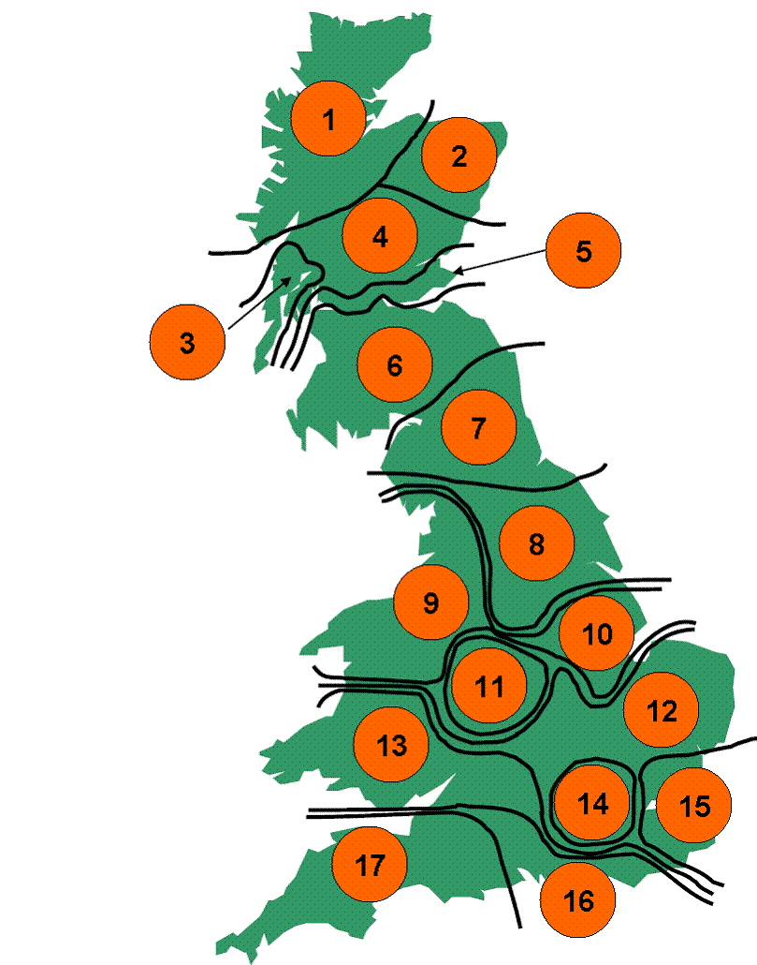
Zone | Tariff (£/MW)
Z1 | 37,641.13
Z2 | 29,424.82
Z3 | 29,370.78
Z4 | 21,609.09
Z5 | 12,713.70
Z6 | 11,159.15
Z7 | 6,892.42
Z8 | 3,124.84
Z9 | 2,125.10
Z10 | 1,684.18
Z11 | 2,610.33
Z12 | 646.17
Z13 | 1,282.68
Z14 | 646.17
Z15 | 650.25
Z16 | 2,126.04
Z17 | 4,213.39
Table 1.1 – Charge Tariff

1.4 Closure and Capacity reduction – Connected Generation

In the event of notification of a reduction in generating capacity or complete plant closure, Connected Generators will be liable for up to two years Wider Cancellation Charge based on notice of reduction or closure. Please note that the tariff is applicable from the date of notice.

Years notice | % liability of wider cancellation charge
2 | 0%
1 | 75%
0 | 100%
Table 1.2 – Notice Periods

This liability replaces the previous liability which was equal to Transmission Network Use of System (TNUoS) charges at their contracted capacity.

For comparison, the link below shows the forecast future TNUoS tariffs.
http://www2.nationalgrid.com/UK/Industry-information/System-charges/Electricity-transmission/Approval-conditions/Condition-5/

2.1 Inputs

The wider cancellation charge is calculated using each TOs forecast of both load related and non load related wider capex. The apportionment of wider capex to each zone is based on the following factors.

Input | Source/Fixed Factor | Description
User Risk Factor | 50% | The share of the wider risk between generation and consumers.
Global Asset Reuse Factor | 33% | The percentage of the wider transmission assets which a TO could potentially reuse on another project.
Boundary levels | Gone Green 2013 as shown in ETYS 2013 | Depth of each SYS boundary multiplied by the increase in required capability on that boundary.
Boundary non compliance factors | Gone Green 2013 as shown in ETYS 2013 | Ratio between available capacity and required capability on each boundary.
Generation base | Contracted Background as shown in ETYS 2013 | Current and Future Generation by zone.
Capex data | April 2013 RIIO T-1 | Sum of TO’s Capex excluding any attributable works cost.
Table 2.1 – Calculation Inputs

Please note that for further information on boundary compliance, future reinforcements, which zones impact on each boundary, capabilities and required transfers please refer to Chapter 3 of the Electricity Ten Year Statement (ETYS) which can be accessed by following the link below:

http://www2.nationalgrid.com/UK/Industry-information/Future-of-Energy/Electricity-ten-year-statement/Current-statement/
3. Calculation Variables 2014/15

This section shows details of the capital expenditure (capex) figures and boundary data that feed into the calculation of the wider cancellation charge tariff.

3.1 Capex

Table 3.1 shows the load related (LR) and non load related (NLR) capex figures for each of the three current onshore TOs, namely National Grid Electricity Transmission (NGET), Scottish Hydro Electric Transmission (SHE Transmission) and Scottish Power Transmission (SPT), for the 2014/15 period;

 | £m
NGET LR Capex | 737
NGET NLR Capex | 360
NGET Attributable | -350
NGET Wider Capex | 747
SHE Transmission LR Capex | 542
SHE Transmission NLR Capex | 15
SHE Transmission Attributable | -315
SHE Transmission Capex | 242
SPT LR Capex | 297
SPT NLR Capex | 91
SPT Attributable | -208
SPT Wider Capex | 180
Total | 1,169
Table 3.1 – Capex Figures
* The table above shows a forecast of capex figures for the three current onshore TOs for the 2014/15 period less any attributable capex costs which relate to local rather than wider works.

2.2 Boundary Data

Table 3.2 shows by zone the boundary capabilities, required increase in capabilities and compliance factors used to calculate the 2014/15 tariff:

Boundary | Boundary Capability (MW) | Required Capability Increase (MW) | Compliance Factor
B1 | 450 | 762 | 42%
B2 | 1,600 | 1,049 | 100%
B3 | 350 | 51 | 100%
B4 | 1,700 | 1,151 | 88%
B5 | 3,050 | 888 | 100%
B6 | 2,700 | 1,115 | 81%
B7 | 3,691 | 1,192 | 93%
B8 | 10,669 | 528 | 100%
B9 | 10,889 | 649 | 100%
B10 | 6,051 | 267 | 100%
B11 | 10,218 | 215 | 100%
B12 | 4,338 | 701 | 100%
B13 | 2,201 | 54 | 100%
B14 | 9,633 | 644 | 100%
B15 | 5,817 | 55 | 100%
B16 | 15,264 | 489 | 100%
B17 | 5,049 | 139 | 100%
Table 3.2 – Boundary Data

4 Forecasts

4.1 Capex

Table 4.1 shows the forecast load related and non load related capex figures for the three financial years beyond 2014/15 shown section 2.1 of this document:

 | 15/16 £m | 16/17 £m | 17/18 £m
NGET LR Capex | 974 | 1,397 | 1,266
NGET NLR Capex | 454 | 622 | 661
NGET Attributable | -263 | -247 | -193
NGET Wider Capex | 1,165 | 1,772 | 1,734
SHE Transmission LR Capex | TBC | TBC | TBC
SHE Transmission NLR Capex | TBC | TBC | TBC
SHETL Attributable | TBC | TBC | TBC
SHE Transmission Capex | TBC | TBC | TBC
SPT LR Capex | TBC | TBC | TBC
SPT NLR Capex | TBC | TBC | TBC
SPT Attributable | TBC | TBC | TBC
SPT Wider Capex | TBC | TBC | TBC
Total | TBC | TBC | TBC
Table 4.1 – Forecast Capex

4.2 Tariffs

Table 4.2 shows the forecast of the wider cancellation charge tariff for the three financial years beyond the published statement shown in section 1.3 of this document:

Zone | 15/16 Tariff (£/MW) | 16/17 Tariff (£/MW) | 17/18 Tariff (£/MW)
Z1 | TBC | TBC | TBC
Z2 | TBC | TBC | TBC
Z3 | TBC | TBC | TBC
Z4 | TBC | TBC | TBC
Z5 | TBC | TBC | TBC
Z6 | TBC | TBC | TBC
Z7 | TBC | TBC | TBC
Z8 | TBC | TBC | TBC
Z9 | TBC | TBC | TBC
Z10 | TBC | TBC | TBC
Z11 | TBC | TBC | TBC
Z12 | TBC | TBC | TBC
Z13 | TBC | TBC | TBC
Z14 | TBC | TBC | TBC
Z15 | TBC | TBC | TBC
Z16 | TBC | TBC | TBC
Z17 | TBC | TBC | TBC
Table 4.2 – Forecast Tariffs

Please note that the forecast figures shown in table 4.2 are calculated using the current capability and transfer data and the forecast capex figures from the three onshore TOs. These figures are indicative and therefore subject to change as capex forecasts are updated by the transmission companies on an annual basis.

5 Cancellation Charge Secured Amount

Prior to the trigger date defined within construction agreements, the cancellation charge secured amount will be the same as the cancellation charge as set out in the cancellation charge statement for the relevant security period, i.e. 100%

On or after the trigger date, the cancellation charge secured amount will be the percentage of the cancellation charge set out below.

- Prior to (and including) the key consents in place date 42%
- From the key consents in place date 10%

These percentages will be reviewed at the start and mid-point of the Transmission price control period, and only changed beyond this in exceptional circumstances to aid stability and certainty.

Contact

Should you have any questions please contact your Customer Account Manager, our Electricity Customer Team general Number (01926 654634) or on the following email address: transmissionconnections@nationalgrid.com

