SSEP External Governance Groups

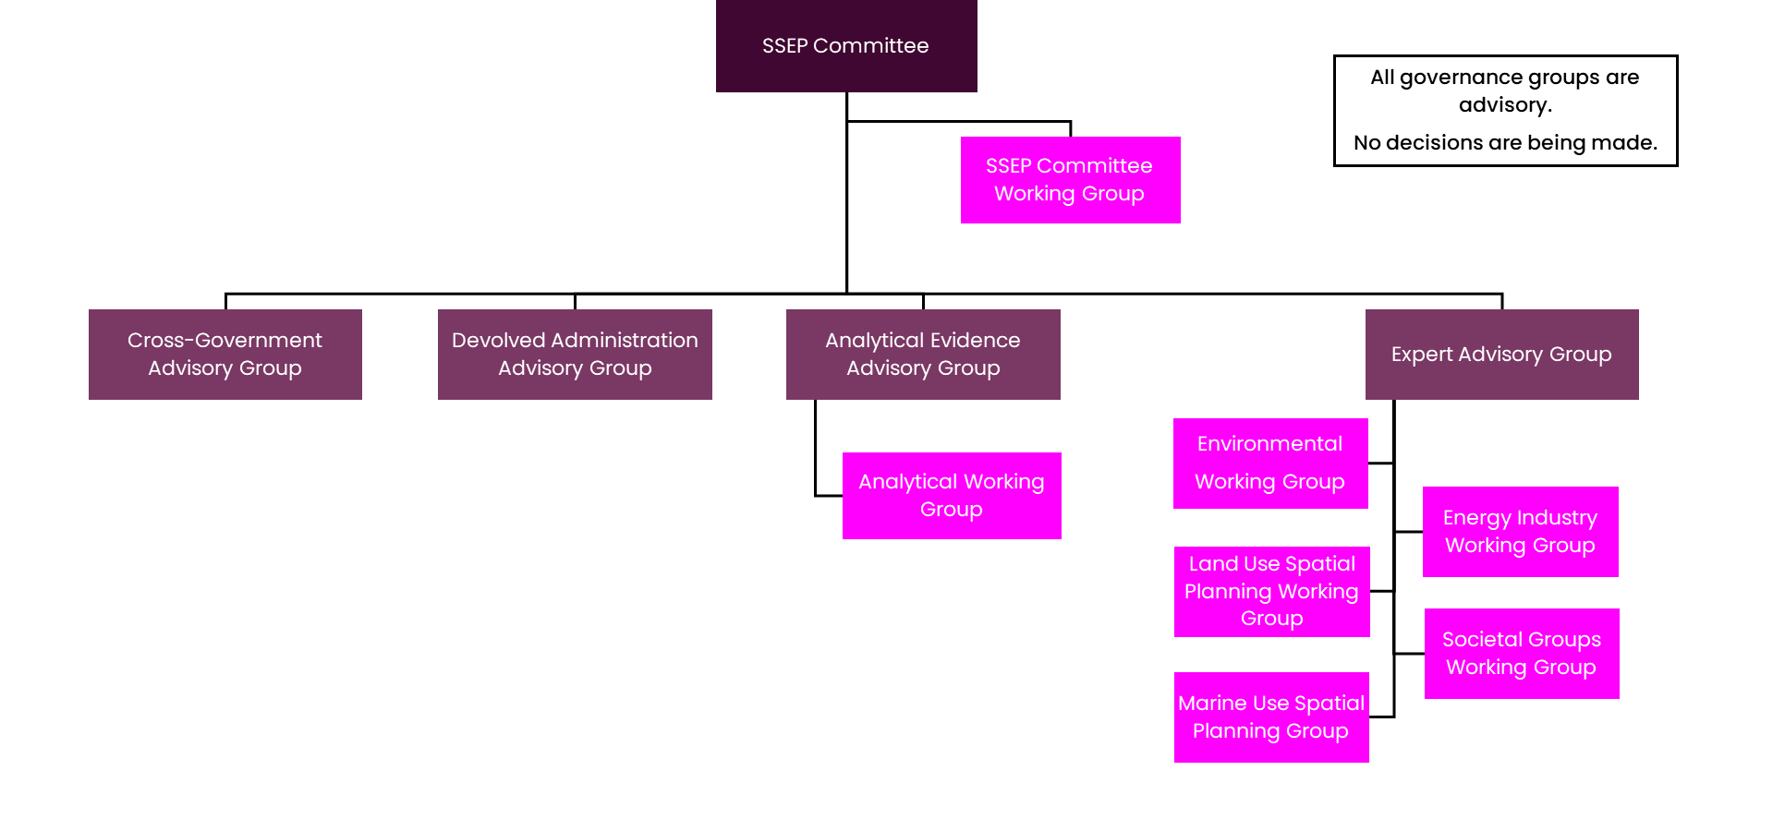
Governance Structure

Terms of Reference
Group | Purpose & Scope | Membership | Frequency & Duration
SSEP Committee | This group is responsible for providing strategic direction and advice on the development and production of the SSEP. It is the highest-level governance group for the SSEP programme. | - NESO (Chair)  - DESNZ  - Ofgem  - Scottish Government  - Welsh Government | Bi-monthly  2 hours
SSEP Committee Working Group (SCWG) | This group is responsible for supporting the SSEP Committee. It seeks to manage risks and actions for the committee, ensuring it interacts effectively with the other governance groups. | - NESO (Chair)  - DESNZ  - Ofgem  - Scottish Government  - Welsh Government | Monthly  1 hour
Cross-Government Advisory Group (CGAG) | This group provides strategic direction and advice from representatives on wider sectoral demands on land and sea. | - DESNZ (Chair)  - NESO  - Representatives from various UK government departments, including the Wales Office and the Scotland Office. | Monthly  1.5 hours
Devolved Administration Advisory Group (DAAG) | This group provides strategic direction and advice relevant to devolved issues. | - NESO (Chair)  - DESNZ  - Scottish Government  - Welsh Government | Ad hoc  1 hour
Analytical Evidence Advisory Group (AEAG) | This group delivers oversight and assurance on the modelling process and analytical issues. | - NESO (Chair)  - DESNZ  - Ofgem  - Scottish Government  - Welsh Government | Monthly  2 hours
Analytical Working Group (AWG) | This group is responsible for supporting the AEAG. The AWG feeds into the AEAG and discusses the detailed modelling topics underpinning the SSEP methodology. | - NESO (Chair)  - DESNZ  - Ofgem  - Scottish Government  - Welsh Government | Every 3 weeks  2 hours
Expert Advisory Group (EAG) | This group provides technical insight and advice on the SSEP, based on engagement with environmental, land, marine, energy industry and societal groups. The EAG will challenge, review and weigh up benefits and opportunities across all categories of expertise. | - NESO (Chair)  - DESNZ  - Ofgem  - Scottish Government  - Welsh Government  - Representatives from each of our stakeholder working groups across environment, land, marine, energy industry and society. | Bi-monthly  1.5 hours

