**GB Inertia Forecasting with Regional Extrapolation (NIA2_NGESO048) additional material**

The improvements within the existing inertia forecasting from using the neural network model, TSMixer, can be seen in both the table and in Figure 1 below.

|  |  |  |  |  |
| --- | --- | --- | --- | --- |
| **metrix** | **TSMixer** | **LGBM** | **Improvement ratio (lgbm:tsmixer)** | **Percentage improvement** |
| RMSE | 0.77 | 3.04 | 3.95 | 74.67% |
| MAPE | 2.3% | 8.8% | 4.10 | 75.59% |

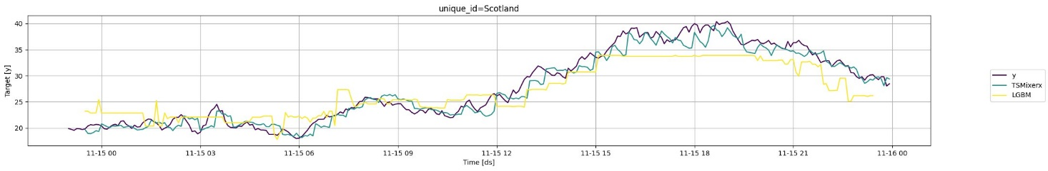

Figure 1: Comparison between LGBM and TSMixer inertia forecasting results versus Expected Metered Inertia (y)

Figure 2 outlines the inertia forecast across 24 hours using the model and predictors for other GB regions

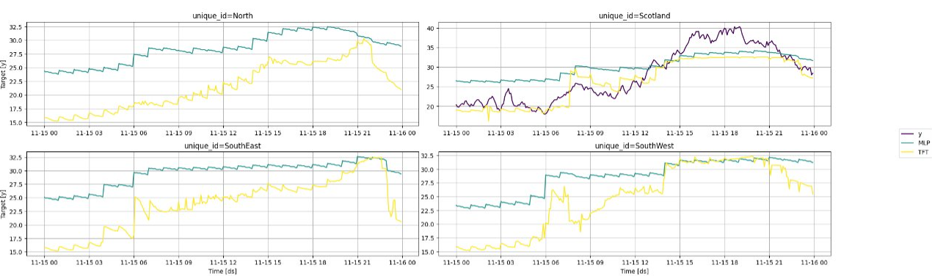

*Figure 2: 15 Nov - Per 4 areas: Inertia Forecasting based on extension of Scotland Model (yellow trace), ESO expected inertia ( green trace - linear combination of sum of rotating inertia and demand). Metering inertia (purple trace – only available in Scotland)*

The total UK inertia prediction is calculated by combining the 4 areas. As expected from previous results, this showed large discrepancies compared to ESO total UK inertia (Figure 3).

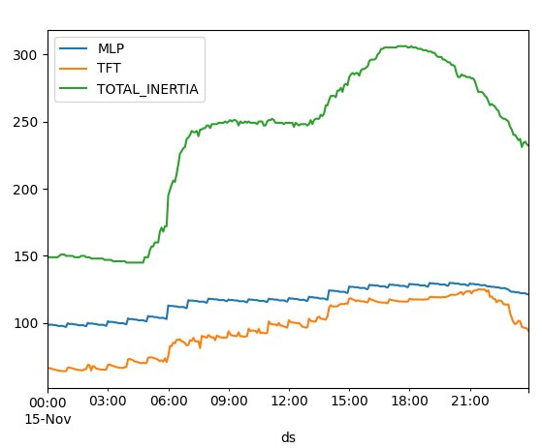

*Figure 3: Total Inertia prediction (Blue-MLP model, Orange-TFT model) compared to ESO expected total inertia*