**NIA2_NGESO032 Progress Report 22-23 Appendix**

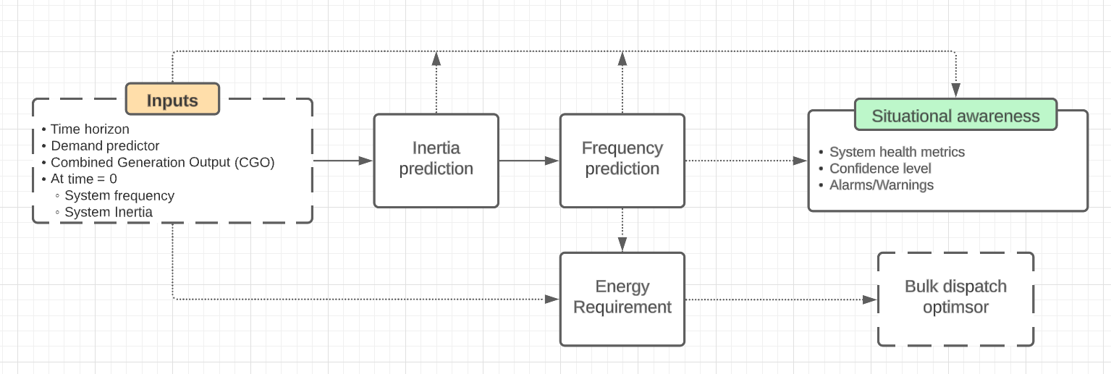

Figure 1. The block diagram presents an end-to-end framework of course correction tool. It consists of two key components: predictive models for inertia and frequency, and the energy requirement. The energy requirement is then fed into the bulk dispatch instructor.

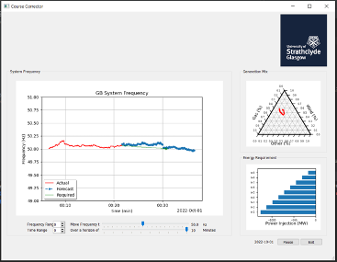

Figure 2. A snapshot of a demonstrator application developed using Python programming language